To prepare for the unknown, each home should have a 72-hour Disaster Survival Kit. You will need to pack some essential items to help you and your family survive, whether you stay at home or leave it during a disaster.
Drinking Water: 
- One gallon per person/per day in unbreakable containers, Avoid using containers that will decompose or break (such as milk cartons or glass bottles). A normally active person needs to drink at least two quarts of water each day. Hot environments and intense physical activity can double that amount. Children, nursing mothers, and ill people will need more. 
- Don’t forget to add additional water for mixing formula if you have children and for your pets. Rotate the drinking water each year. 
- Food preparation and sanitation require another two quarts (minimum) per person daily. 
- Purchased bottled water that has been sealed is best for storage. It meets FDA guidelines for food and is not as vulnerable to temperature changes as unsealed water 
- Tip: Purchase water this year and use it for drinking next year. This allows for rotation on an annual basis and keeps the water fresh. Yes water can go bad!
Water for sanitation use: 
- Store extra containers of water to be used for flushing toilets, cleaning, and bathing. 
- Purchase water purification tablets (Halazone) to be used if you still have running water but are told to boil water before using it. This allows you to fill the bathtub and other containers without purchasing expensive drinking water. 
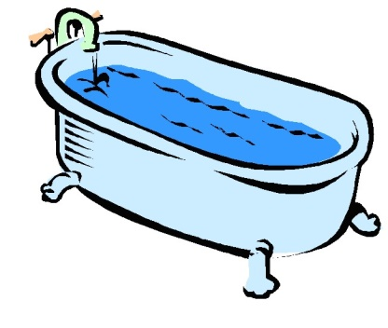
- Tip: Keep plastic containers (milk jugs and other containers) and fill them with water when a storm threatens. You can put these items in the freezer to keep food cold longer in the event that the electricity goes out.

Non-perishable Food: 
- Maintain at least 3-7 days of food for each member of the family. 
- Small, preferably single serving cans (should not require cooking or refrigeration).
- Ready-to-eat canned meats, fruits and vegetables. 
- Canned juices, milk, soup (if powdered, store extra water). 
- Staples – sugar, salt, pepper in water proof containers. 
- High energy foods like crackers, granola bars, trail mix. 
- Raw vegetables that do not need refrigeration.
- Fresh bread.
- Comfort/stress foods – cookies, hard candy, sweetened cereals, lollipops, instant coffee, tea bags.
- Sterno for cooking.
- Vitamins
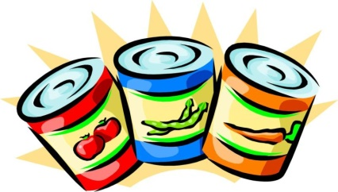
- Food for infants
- Paper cups, plates, and plastic utensils
- Non-electric can opener
- Aluminum foil
- Plastic storage containers
- Lots of ice (you can freeze your water supply)
- Tip: Purchase only items that you like to eat and would eat even without a storm. Rotate these items by using them Dec-May each year and purchasing new items Jan-May.
Baby Needs: 
- Special foods (enough for several days) 
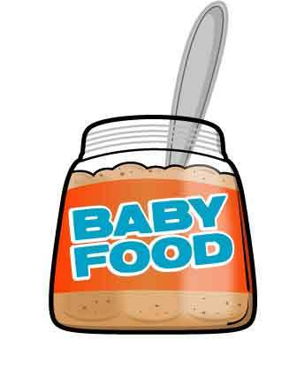
- Formula (enough for several days) 
- Extra diapers 
- Medicines (get a copy of prescription) 
- Blankets 
- Diaper Rash Ointment 
- Baby Wipes 
- Powder 
- Bottles 
- Pacifier 
- Favorite toy/blanket 
- Medicine dropper 
- Diaper-rash ointment
Sanitation
- Toilet paper, towelettes, soap, baby wipes, liquid hand sanitizer
- Liquid detergent
- Feminine supplies
- Personal hygiene items (toothpaste, deodorant, shampoo etc.)
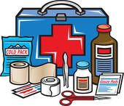
- Plastic garbage bags, ties (for personal sanitation uses)
- Plastic bucket with tight lid
- Household chlorine bleach, disinfectant
- Plenty of absorbent towels
First Aid Kit
- Assemble a first aid kit for your home and one for each car.
- Adhesive bandages various sizes -- Sterile gauze pads (various sizes)
- Germicidal hand wipes or waterless alcohol-based hand sanitizer
- Non-latex gloves -- Adhesive tape -- Anti-bacterial ointment -- Antiseptic spray
- Cold packs (non-refrigerated type) – Scissors – Tweezers -- Rubbing alcohol
- CPR breathing barrier, such as a face shield -- Thermometer, Safety pins.
Non-Prescription Drugs
- Aspirin or non-aspirin pain reliever, Benadryl, peroxide
- Anti-diarrhea medication, Antacid (for stomach upset)
- Syrup of Ipecac (use to induce vomiting if advised by the Poison Control Center)
- Laxative
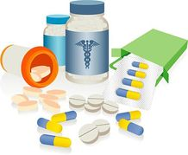
- Activated charcoal (use if advised by the Poison Control Center)
Prescription Drugs
- Heart and high blood pressure medication
- Insulin (enough for a 30 day supply)
- Hearing Aid and extra batteries
- Prescription drugs
- Denture needs
- Contact lenses and supplies
- Extra eye glasses
- Tip: If your insurance will allow, get a 90 day supply of prescriptions and have at least a 30 day supply on hand

Clothing and Bedding
Include at least one complete change of clothing and footwear per person.
- Sturdy shoes or work boots
- Towels
- Raingear
- Blankets or sleeping bags and Pillows
- Hat and gloves
- Sunglasses
- Tent
- Lawn chairs
Entertainment
- Games
- Books
- Cards
- Extra batteries for games
- Coloring books, crayons.
Miscellaneous
- Wind-up or battery-operated clock
- Paper, pencil
- Needles, thread
- Camping utensils
- Map of the area (for locating shelters) and returning to the area.
- Cash or traveler's checks
- Tip: Have enough cash to sustain you through a 2 week period. Without electricity, most businesses (if open) will not accept credit cards and may not accept traveler’s checks.
- Emergency preparedness manual
- Citronella candles

Tools and Supplies:
Masking and/or duct tape Handsaw Razor knife Ax or chain saw
Nails and screws Ladder Portable generator Wheelbarrow
Bucket/mop, broom Fire extinguisher Hammer Screwdriver
Pliers/wrenches Rope All-purpose cleaner Sandbags
Shovel, rake Plywood Tarp Bleach
Tarps to cover roof Portable a/c unit BBQ grill Propane tanks
Utility knife Compass Signal flare Bug repellant
Sun screen (2-3) Flashlights Extra batteries Matches
Whistle Battery operated radio

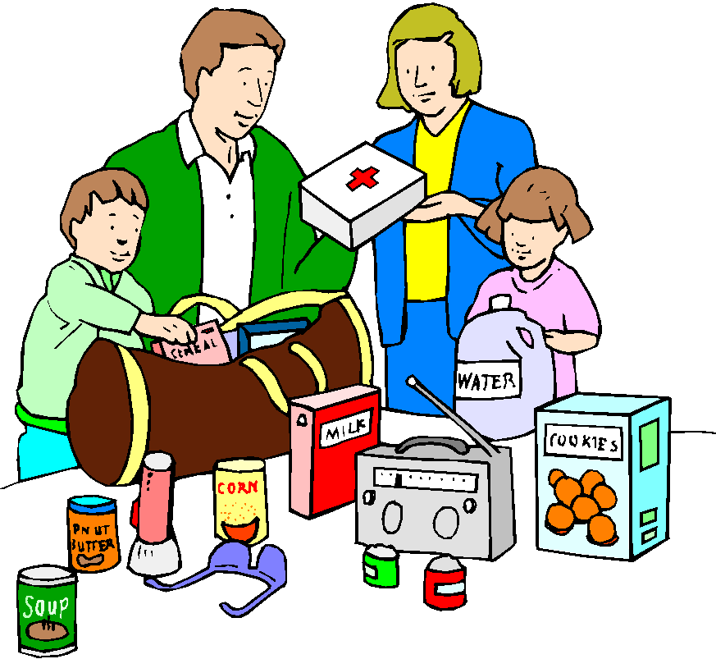

Not evacuating and staying home?
- Ensure you have enough food, water, medications, and other supplies in your survival kit to last at least 2 weeks

- Turn refrigerator to coldest setting and keep closed. 

- Turn off propane tanks. 

- Unplug small appliances.

- Fill bathtub and other containers with water for cleaning and flushing. Additional water is stored for drinking.

- Cover all windows and other openings with hardened protections. If you do not have manufactured shutters, cut plywood and secure to protect the windows. 

- Close all interior doors and brace outer doors. 

- Select an interior room to use as a safe room.

- Plan as though you were evacuating and have enough cash on hand to sustain purchasing of gas, food, and other supplies in the days following the storm.

- If you have a generator, ensure you have enough gas on hand to sustain usage for several days.

- Ensure you have sufficient medications in case you are confined to your home for several days.

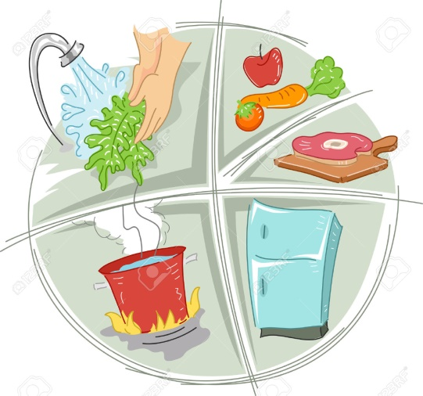
- Plan to cook on a camp stove or grill in the days immediately after the storm passes.

Emergency Contact Numbers and Websites:
National Hurricane Center: http://www.nhc.noaa.gov/
WFTV: http://www.wftv.com/
Orlando Non-Emergency Police Number: 321-235-5300
Orange County Non-Emergency Police: 407-254-7280
Hugh Cotton Insurance 407-898-1776
Red Cross:
Florida’s Space Coast Chapter – 386 - 226-1400
Greater Orlando Chapter – 407- 894-4141
Mid-Florida Chapter – 863- 294-5941
Southwest Florida Chapter – 941- 379-9300
Tampa Bay Chapter – 813- 348-4820
FEMA: https://www.fema.gov/
Florida Disaster - http://www.floridadisaster.org/index.asp

